Teacher Notes for
Using Molecular and Evolutionary Biology to Understand HIV/AIDS and Treatment
Dr. Ingrid Waldron, University of Pennsylvania, 2014

This discussion/worksheet activity can be used to introduce students to the molecular and evolutionary biology of HIV/AIDS and treatment or to reinforce and deepen student understanding of this topic. The Student Handout includes relevant information in prose and diagrams, links to web readings, and questions designed to stimulate student understanding of the biology of HIV, AIDS and treatment and to reinforce student understanding of some aspects of molecular biology and natural selection. If you prefer to introduce the biology of HIV/AIDS in some other way, you can shorten the Student Handout as appropriate to supplement your presentation.

This activity is designed for use with high school students or college students in a non-majors biology course. The explanations and questions in the Student Handout are appropriate for students who have been introduced to natural selection and basic cellular and molecular biology, including transcription and translation. Hands-on activities that can be used to introduce natural selection and transcription and translation are available at http://serendipstudio.org/sci_edu/waldron/#evolution and http://serendipstudio.org/sci_edu/waldron/#trans, respectively.

Learning Goals
Biology of HIV/AIDS and Treatment
- HIV (the Human Immunodeficiency Virus) contains RNA (the genetic material) and a few specialized viral enzymes, surrounded by protein layers and a membranous envelope with viral glycoproteins.
- Like all viruses, HIV can only reproduce inside cells, using the molecules and organelles of the cell to produce new HIV viruses.
- HIV replication requires specialized viral enzymes including:
- reverse transcriptase, which makes double-stranded DNA using the information in the viral RNA
- integrase, which incorporates the viral DNA into the infected cell’s DNA
- protease, which cuts the multi-protein chain produced by translation of viral mRNA into the proteins of a mature virus.
- HIV replication also requires host cell RNA polymerase and nucleotides for transcription, host cell ribosomes and amino acids for translation, and host cell membrane to form the envelope of new HIV viruses.
- HIV typically infects Helper T cells. Helper T cells stimulate other immune cells, and this stimulation is crucial for effective immune responses. HIV infection kills Helper T cells, so an untreated HIV infection eventually results in a weakened immune system which cannot effectively defend the body against infections, and the person develops AIDS (Acquired Immunodeficiency Syndrome).
- HIV is a retrovirus so medications to treat HIV infection are called antiretroviral medications. Antiretroviral medications interfere with the action of viral molecules such as reverse transcriptase, integrase or protease. This illustrates the general principle that to minimize side effects, medications should interfere with molecules specific to the infectious virus (or other infectious organism) and should not interfere with molecules needed by our cells.
- In a person treated with a single antiretroviral medication, the HIV population rapidly evolves resistance to that medication. Natural selection is particularly rapid because many mutations are available for selection due to the high rate of errors by reverse transcriptase and the high rate of production of new HIV viruses.
- HAART (Highly Active Antiretroviral Therapy) uses several antiretroviral medications simultaneously and these medications work against different molecular targets. HAART has dramatically increased long-term success in treating HIV because HAART reduces the evolution of medication resistance.
  - The combination of several antiretroviral medications very much reduces the replication of HIV, which reduces the chance for resistance mutations to occur.
  - Even if a resistance mutation for one of the medications does occur, the other medications will usually prevent rapid reproduction of this mutated HIV.

Review of Some Aspects of Molecular Biology and Natural Selection
- Genes code for proteins. The nucleotide sequence in genes in DNA codes for the nucleotide sequence in mRNA (transcription) which codes for the sequence of amino acids in a protein (translation).
- Natural selection results in increases in the frequency of alleles for adaptive characteristics in a population; which characteristics are adaptive varies depending on the environment.

In accord with the Next Generation Science Standards:
- This activity helps to prepare students for the Performance Expectation, HS-LS4-4, "Construct an explanation based on evidence for how natural selection leads to adaptations of populations."
- Students learn the following Disciplinary Core Ideas:
- "Genes are regions in the DNA that contain the instructions that code for the formation of proteins." (LS1.A – Structure and Function)
- "The instructions for forming species' characteristics are carried in DNA." (LS3.A – Inheritance of Traits)
- "Natural selection occurs only if there is both (1) variation in the genetic information between organisms in a population and (2) variation in the expression of that genetic information – that is, trait variation – that leads to differences in performance among individuals. The traits that positively affect survival are more likely to be reproduced, and thus are more common in the population." (LS4.B – Natural Selection)
- Students engage in recommended Scientific Practices, including
"Constructing Explanations" – Students should be able to:
- "Construct their own explanations of phenomena using their knowledge of accepted scientific theory and linking it to models and evidence."
- "Offer causal explanations appropriate to their level of scientific knowledge."
"Obtaining, Evaluating and Communicating Information" – Students should be able to:
- "Read scientific… text, including tables, diagrams, and graphs, commensurate with their scientific knowledge and explain the key ideas being communicated."
(This Scientific Practice is fostered particularly by the Extension Activity recommended on page 5 of these Teacher Notes.)
- This activity provides the opportunity to discuss several Crosscutting Concepts: "Cause and effect: Mechanism and explanation", "Structure and function", and "Stability and change".

Suggestions and Additional Information for Discussion of Questions
To maximize student participation and learning, I suggest that you have your students work in pairs (or individually or groups of three) to complete groups of related questions and then have a class discussion after each group of related questions. In each discussion, you can probe student thinking and help them develop a sound understanding of the concepts and information covered before moving on to the next group of related questions.

In discussing questions 3 and 4, you may want to ask your students why transcriptase would be a reasonable name for the enzyme RNA polymerase; this should help students realize that reverse transcriptase is a logical name for the viral enzyme that carries out a process that is the reverse of transcription. You may want to ask your students why the enzyme names integrase and protease are logical names for these viral enzymes. You also may want to clarify that the synthesis of viral DNA is a two-step process; first reverse transcriptase copies viral RNA to make a single strand of viral DNA and then reverse transcriptase copies this DNA strand to make double-stranded viral DNA.

Question 6 has multiple purposes, including introducing students to the important information that reverse transcriptase makes lots of mistakes and thus produces lots of mutations, reminding students that most mutations are not beneficial, and stimulating students to think about the need for viruses to bind to host cells in order to reproduce. You may want to contrast the relatively high rate of errors by reverse transcriptase with the excellent proofreading and correction abilities of DNA polymerase enzymes (roughly one error per 30,000 nucleotides for reverse transcriptase vs. less than one error per billion nucleotides for DNA polymerase).

The section on "Treatment of HIV Infections" provides the opportunity to reinforce understanding of the molecular aspects of HIV and the process of natural selection, and also to discuss how medical science can progress step-by-step to produce increasingly effective treatments.

Reverse transcriptase is a globular protein with a groove that contains the active site for the polymerase activity (see e.g. http://www.macroevolution.net/reverse-transcriptase-2.html#replication ); the diagram of reverse transcriptase in the figure on page 4 of the Student Handout can be thought of as showing a cross-section of the groove, while omitting most of the reverse transcriptase protein.
The effectiveness of HAART has dramatically improved the prognosis for HIV-infected people. However, many patients experience significant problems with HAART, as indicated by the following observations. For a sample of HIV-infected people treated with HAART, one-third had changed at least one medication within the first year (due to side effects and/or resistance to one of the medications). By four years, three-quarters of the patients had changed medications, typically several times.

You will probably also want to mention that another important aspect of treatment of HIV-infected patients is the treatment of opportunistic infections.

Question 8 is designed to help students think about natural selection in terms of increased frequency of individuals with adaptive characteristics within a population. They should also notice that whether a characteristic is adaptive varies depending on the specific environment. (Although not stated explicitly, students should assume that the HIV viruses in this population are sensitive to the integrase inhibitor and protease inhibitor.) Discussion of this question should also help students to understand that HAART is effective in reducing the evolution of antiretroviral-resistant HIV in large part because a single mutation that increases resistance to one type of antiretroviral medication does not confer a substantial increase in fitness if other antiretroviral medications prevent viruses with that single mutation from reproducing.

In discussing question 9, you may want to compare the biology of viruses and bacteria and use the principle presented to explain why it has generally been more difficult to develop effective medications against viral infections such as colds and flu, whereas many bacterial infections have been effectively treated by antibiotics that target the many bacteria-specific molecules.

Natural selection is much faster in HIV than in humans due in large part to the much shorter generation time and larger population size for HIV. About 10 billion HIV viruses are produced per day in an HIV-infected person compared to approximately 400,000 human births per day worldwide. Reverse transcriptase has a high error rate compared to DNA polymerase so there are lots of mutations available for selection in the HIV population, but recombination is a greater source of genetic variation for humans.

Question 12 alerts students to the possibility of becoming infected with a strain of HIV that is resistant to one or more antiretroviral medications, e.g. by having unprotected sex with an HIV-infected individual who has been treated with antiretroviral medications.

Possible Additions to the Student Handout
The last two pages of these Teacher Notes can be inserted as the second part of the section on "How HIV Causes AIDS" at the end of page 3 of the Student Handout. This addition will help students to learn about three topics:
- Helper T cells are called CD4 cells because they have the CD4 protein on their surface. To infect a cell, a glycoprotein on the surface of HIV must bind to a CD4 molecule (and a co-receptor) on the surface of the Helper T cell.

- There is a substantial clinical latency period when the immune system is able to control the levels of HIV and replace the many Helper T cells killed by HIV infection. When the body becomes unable to replace the many Helper T cells that are killed, Helper T cell levels fall so low that the immune system is unable to defend against opportunistic infections, so clinical latency ends and the person has AIDS (Acquired Immunodeficiency Syndrome) and eventually dies.

The ongoing destruction and replacement of Helper T cells during clinical latency is an example of the general dynamic nature of cellular and molecular processes in our bodies (similar to the ongoing replacement of body cells discussed in the "Understanding the Biology of Cancer" activity available at http://serendipstudio.org/exchange/bioactivities/cancer). The minor increases in HIV concentration observed at some times during clinical latency are often the result of immune activation when a person gets an infection or immunization (see http://ftguonline.org/ftgu-232/index.php/ftgu/article/view/1970/3936 for additional explanation).

- HIV-infected individuals are most likely to transmit their infection when levels of HIV in blood, semen and vaginal secretions are high, in the month or two after initial infection (often before the person realizes that he or she is HIV-infected) and in the late stages once AIDS has developed.

If you would like to reinforce student understanding of natural selection, you can incorporate the following question the on page 6 of the Student Handout.
Explain how the evolution of resistance to antiretroviral medications illustrates the three necessary conditions for natural selection:
- For natural selection to occur, different individuals in a population must have different characteristics.
- For natural selection to occur, the different characteristics of different individuals must contribute to differences in fitness (i.e. differences in ability to survive and reproduce).
- For natural selection to occur, the characteristics that affect fitness must be heritable (i.e. passed by genes from one generation to the next).

Extension Activity
This extension activity engages students in the scientific practices of "Asking Questions" and "Obtaining, Evaluating and Communicating Information", including the goals that students should be able to:
- "Distinguish a scientific question… from a nonscientific question…."
- "Ask probing questions that seek to identify the premises of an argument, request further elaboration…"
- "Read scientific… text, including tables, diagrams, and graphs, commensurate with their scientific knowledge and explain the key ideas being communicated."
- "Engage in critical reading of… media reports of science and discuss the validity and reliability of the data, hypotheses and conclusions."

As students ask questions about HIV/AIDS that are not readily answered based on the information you have available, you can keep a record of these questions. You can also ask students what else they would like to know about HIV/AIDS. Then students can use web resources and any relevant print material you have available to search for answers to these questions. The following websites are informative, reliable and written at an appropriate level for high school students.
- A wealth of reliable information, including the biology of HIV, HIV risk factors, symptoms, testing and diagnosis, treatment and prevention, is available at http://www.niaid.nih.gov/topics/hivaids/Pages/Default.aspx
- A very informative source on HIV/AIDS is http://www.avert.org/ (see e.g. "Introduction to Prevention", available at http://www.avert.org/prevent-hiv.htm and "HIV and AIDS vaccine", available at http://www.avert.org/aids-vaccine.htm ).
- Statistics, information about testing, and general information about HIV are available at http://www.cdc.gov/hiv/default.htm

For an excellent source concerning multiple aspects of evolution and HIV, see Chapter 1 in the book, Evolutionary Analysis (Fourth Edition by Freeman and Herron, 2007, Pearson/Prentice Hall).

An interesting account of the origin and early spread of AIDS is summarized in "Chimp to Human to History Books: the Path of AIDS", available at http://www.nytimes.com/2011/10/18/health/18aids.html?_r=1&pagewanted=all
Possible Addition to Student Handout, beginning on the top of page 4:

Helper T cells are also called CD4 cells because they have CD4 molecules on their surface. These CD4 molecules contribute to the normal functioning of Helper T cells.

7. Explain why these CD4 molecules make the Helper T cells vulnerable to HIV infection. (Hint: See the figure on page 2.)

The following figure shows the typical time course of an untreated HIV infection.
- The concentration of HIV RNA in the blood is shown by the gray line.
- The concentration of Helper T cells in the blood is shown by the black line (CD4 T-lymphocyte = Helper T cell).
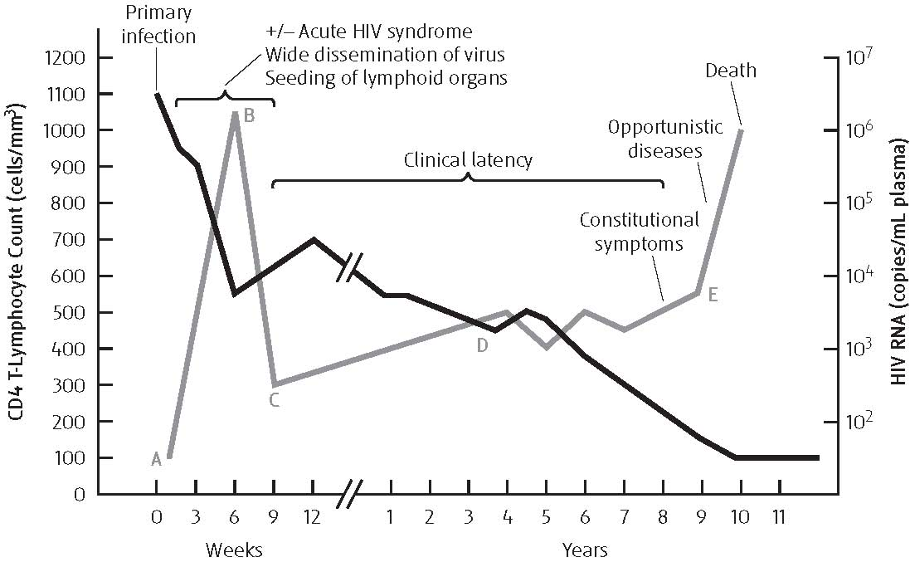
(figure from http://ftguonline.org/ftgu-232/index.php/ftgu/article/view/1970/3936 )

- After initial infection (A), HIV levels increase and Helper T cell levels fall, until the person's immune system develops an effective response to combat the HIV infection (B). This immune response may result in flu-like symptoms (acute HIV syndrome).
- The body's immune response decreases the levels of HIV (C) and the body is able to replace some of the Helper T cells killed by HIV infection.
- This is followed by a long period during which the immune system is able to combat the HIV infection relatively effectively and replace the many Helper T cells killed by HIV infection (D). This period is called clinical latency, because the HIV infection causes relatively few symptoms during this period.
- If the HIV infection is not treated effectively, the body eventually becomes unable to produce enough Helper T cells to replace the many Helper T cells that are being killed, so Helper T cell levels fall so low that the person becomes vulnerable to opportunistic infections (E). Opportunistic infections are caused by bacteria, viruses and other infectious organisms that can be controlled by a healthy immune system and thus do not cause disease in a healthy person. Constitutional symptoms include fever, weight loss and fatigue.
- An HIV-infected person is said to have AIDS if the Helper T cell levels fall below a certain threshold or if the person has an opportunistic infection or other condition characteristic of advanced HIV infection.

8. Why does a person with an untreated HIV infection typically have a period of multiple years with few symptoms before he or she develops AIDS?

9. HIV-infected people are most likely to transmit their infection to sexual partners in the first month or two after infection or once they develop AIDS and less likely to transmit their infection during clinical latency. Propose a likely explanation for this observation.

These Teacher Notes, the related Student Handout, and other minds-on discussion activities for teaching biology are available at http://serendipstudio.org/exchange/bioactivities. Hands-on, minds-on activities for teaching biology are available at http://serendipstudio.org/sci_edu/waldron/ .
Quotes from Next Generation Science Standards, available at http://www.nextgenscience.org/next-generation-science-standards
Quotes from A Framework for K-12 Science Education: Practices, Crosscutting Concepts, and Core Ideas (available at http://www.nap.edu/catalog.php?record_id=13165 ).
A Framework for K-12 Science Education: Practices, Crosscutting Concepts, and Core Ideas (available at http://www.nap.edu/catalog.php?record_id=13165 ) recommends engaging students in these scientific practices.

